5

Two toy cars, green and yellow, travel along a 3 metre track from opposite ends.

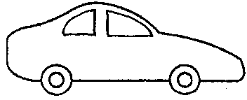
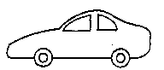
3 metres
START
green
START
1 metre
STOP
yellow

Both cars start at the same time.
They meet 1 metre from the left-hand end, and stop.

(a) Which car was faster?

Tick ONE box ()

❑ | The green car.
❑ | The yellow car.
❑ | Both had the same speed.

(b) All of the following statements are correct. But which is the best explanation for the answer above?

Tick ONE box ()

❑ | The cars travelled towards each other.
❑ | The yellow car went further in the same time.
❑ | The green car travelled a shorter distance than the yellow car.
❑ | The cars met at the same point.
❑ | Another reason: _______________________________________  _____________________________________________________

